TOPIC #2: Challenging Authority & Political Revolutions
Are Political Revolutions Worth the Risk?

GLOBAL I: Laying the Foundation for Understanding
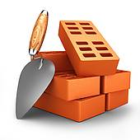
The Enlightenment Challenging Authority

GLOBAL II: Constructing the Topic (Essential Questions)
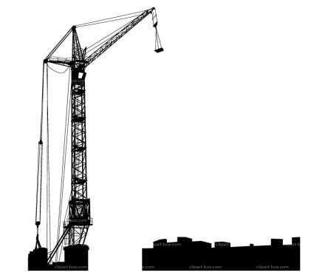
1- How did the Enlightenment thinkers challenge the authority of the royal aristocracy?
____________________________________________________________________________________________________________________________________________________________
2- What were the goals of those conservative leaders assembled at the Congress of Vienna?
____________________________________________________________________________________________________________________________________________________________
3- How did the political goals of liberals and nationalists differ from those of conservatives?
____________________________________________________________________________________________________________________________________________________________
4- What impact did the early Enlightenment thinkers have on political revolutions, like that in France?
____________________________________________________________________________________________________________________________________________________________
5- How did social structure contribute to discontent in Latin America?
____________________________________________________________________________________________________________________________________________________________
6- How did the Haitian Revolution play out and what were the results?
____________________________________________________________________________________________________________________________________________________________
7- Who helped lead other revolutions throughout Latin and South America in the 1800s?
____________________________________________________________________________________________________________________________________________________________

Important Terms | Important People
Global I -  - peninsular  - creole  - mestizo  - mulatto  - censorship  - Natural Rights  - social contract  Global II -  - ideology  - universal manhood suffrage  - autonomy  - recession  - truce  - conservatism  - liberalism  - nationalism | Global I -  - John Locke  - Voltaire  - Baron de Montesquieu  - Mary Wollstonecraft  - Thomas Hobbes  - Jean-Jacques Rousseau  Global II -  - Prince Klemens von Metternich  - Napoleon Bonaparte  - Toussaint L’Ouverture  - Simon Bolivar

Political Revolutions are dangerous undertakings. Based on the examples from our studies, is it worth the risk to wage a political revolution? What benefits make the dangers worth taking?
__________________________________________________________________________________________________________________________________________________________________________________________________________________________________________________________________________________________________________________________________________________________________________________________________________________________________________________________________________________________________________________________________________________________________________________________________________________________________________________________________________________________________________________________________________________________________________________________________________________________________________________________________________________________________________________________________________________________________________________________________________________________________________________________________________________________________________________________________________________________________________________________________________________________________________________________________________________________________________________________________________________________________________________________________________________________________________________________________________________________________________________________________________________________________________________________

